C.W

Task 1:

Consider a String entered by the user which he wants to encrypt and then decrypt the information. Perform this functionality via the filling technique by first inserting the encrypted text in the file then read the encrypted text to decode it back to string.

Input:

Enter String = Hello World

Output:

Normal Text:= Hello World

Encrypted text inserted in file

Igopt&amp;^w{vo

Decrypted text Read then decoded from file

Hello World

(Note: For Encryption the algorithm would be is to take the length of the string then add the

Number based on the index position of the character of the string when inserting into the file)

Example:

ABC = //Here A is at position 1 B is at position 2 and c is at position 3 if we add these position values to their ascii code then the ascii values becomeOriginal values = 65 66 67; modified = 66 68 70 which converts the text to B D F

Task 2:  
Create a CRUD Application where there exists 4 columns of data id, name, designation and years of service. Write some dummy data into the file (either via code or manually) and run three queries to verify your read / write approach

a) Find a person who has a designation of manager and has served atleast 2 years  
b) Delete all data except the above query retrieved data.  
c) Write the same data as the retrieved query data but with incremented IDS and years.

Task 3:

* Create a database system (File) which handles the following schema

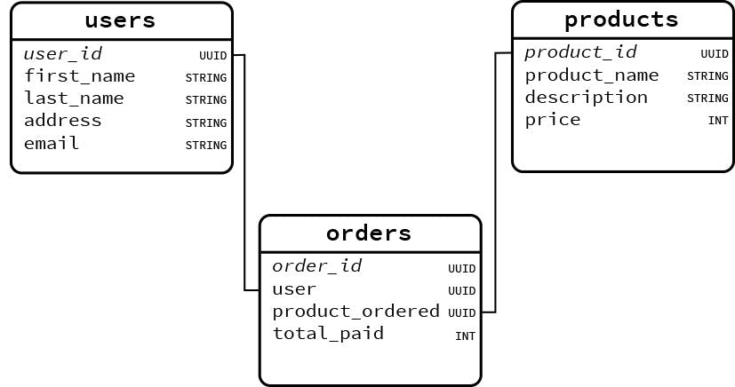

Implement and add dummy data with writing a query to fetch products name who are associated with the user “Linus”.

H.W

Task 4:

**Logging System with Rotating Logs**

**Challenge**: Create a logger that writes logs to a file, and once the file exceeds a certain size (e.g., 1MB), it renames it and starts a new file (log1.txt, log2.txt...).

Task 5:

**To-Do List Manager**

**Scenario**: Create a simple to-do list app that:

* Lets the user add tasks (appended to a file)
* View all tasks
* Mark a task as done (overwrite file with updated content)